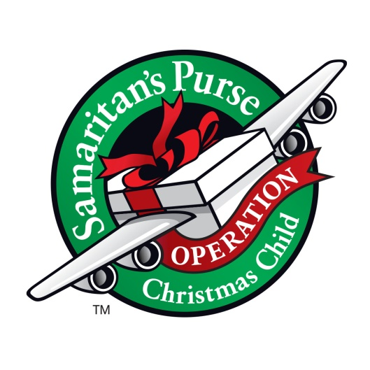
Operation Christmas Child
East Taylorsville Baptist Church supports Operation Christmas Child by packing gift-filled shoeboxes. Our goal at ETBC is to reach children around the world with the Good News of the Lord Jesus Christ through a simple shoebox gift. Nearly half of the children that receive a shoebox have made the decision to follow Christ. God is blessing our shoeboxes and making a difference globally and eternally.
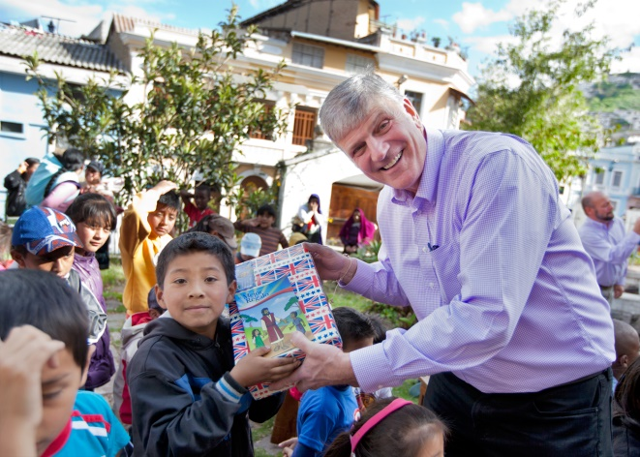
Many ETBC ministry groups work together throughout the year to prepare and pack shoeboxes to be sent around the world. Much time and preparation goes into our Shoebox Packing Party with our kids. A $9 donation is also requested for each box. Why $9? The $9 per shoebox covers delivery to all parts of the world and the Gospel materials that go with the shoebox.
Through your tithes and offerings you are part of helping with a large portion of the shipping costs for our shoeboxes. However, more is needed for all the supplies to fill these boxes and additional shipping. You may feel led to give additional support for this wonderful Gospel outreach throughout the year.
For more information on how you can help, contact Maria Pardue:
Cell: 828-320-0955 Email: mariapardue@bellsouth.net
For more information about Operation Christmas Child, connect with the following link: https://www.samaritanspurse.org/what-we-do/operation-christmas-child/

